**PROGRESS REPORT**

**TASK # 5.8 (Visit to Govt. Girls Higher Secondary School, Khuzdar and STEM awareness in Women’s dated 7th Nov, 2024)**

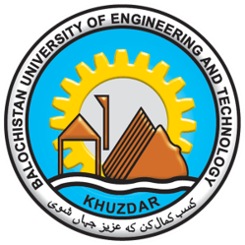

**BIOMEDICAL ENGINEERING DEPARTMENT**

**BALOCHISTAN UNIVERSITY OF ENGINEERING AND TECHNOLOGY, KHUZDAR**

**Activity T5.8 Report Submission: Visit to Secondary School Khuzdar, Balochistan**

**Introduction**

On 07-11-2024, an educational outreach program was successfully conducted at the Secondary School in Khuzdar, Balochistan, aimed at engaging more than 200 female students. The primary objective of this initiative was to introduce the students to the BIOMED 5.0 project and its significance in the realm of modern biomedical engineering technologies, particularly focusing on 4.0 and 5.0 industry technologies.

**Agenda Overview**

**Initial Introduction**

Dr. Wazir Muhammad commenced the session with the recitation of the Holy Quran, setting a respectful and reflective tone for the event. Following this, he provided an introductory overview of the BIOMED5.0 project, detailing its objectives and significance in enhancing biomedical integration. The BIOMED5.0 project aims to modernize and update biomedical engineering curricula by incorporating Industry 4.0 and 5.0 technologies into educational programs. Dr. Wazir emphasized that the project not only focuses on academic enhancement but also aims to promote digital transformation in education, research, and industry. By training academic staff, students, and professionals on these emerging technologies, the BIOMED5.0 project aspires to disseminate knowledge and increase awareness about the importance of integrating modern technologies into healthcare practices. This initial introduction set the stage for a detailed exploration of how these advancements can significantly impact healthcare delivery and medical research, which was further elaborated by Dr. Nazia Ejaz's lecture during the session. Dr. Nazia Ejaz also delivered a lecture on importance of women in STEM.

**Detailed Lecture**

The lecture delivered by Dr. Nazia Ejaz provided an in-depth introduction to Biomedical Engineering, its application in healthcare sector and integration of biomedical technologies with cutting-edge 4.0 and 5.0 technologies. This segment highlighted how these advancements can revolutionize healthcare delivery and medical research. She also highlighted that Promoting women in STEM is essential not only for individual success but also for building a more inclusive, innovative, and balanced society that benefits everyone.

**Key Points Discussed**

**Introduction to Biomedical Engineering:**

Dr. Nazia Ejaz discussed biomedical engineering is an emerging interdisciplinary field that connects biological sciences and principles of engineering to create solutions for health care and medical industries. She also emphasized that Biomedical Engineering is essential for the improvement of healthcare and enhancement of quality of life wellbeing.

**Key Areas of Biomedical Engineering:**

She also discussed key areas of Biomedical Engineering in detail with real world examples and case studies. The discussed key areas include Robotics and Artificial Intelligence, Rehabilitation Engineering, Biomedical Instrumentation, Tissue Engineering, and Biomaterials.

**Advancements in Medical Research:**

Dr. Ejaz discussed how 5.0 technology facilitates faster data transfer rates and lower latency, which are crucial for applications such as telemedicine, remote surgeries, and real-time diagnostics. This can significantly enhance research capabilities by enabling large-scale data analysis and collaboration across institutions.

**The Importance of Women in STEM and the Benefits for Women:**

Dr. Nazia Emphasized on importance and outcomes of STEM education for female Reducing Gender Bias: Research and product development are less affected by gender bias when there are more women in STEM fields. Increased representation of women in these professions leads to advancements in industries such as healthcare, where the development of medical devices and research becomes more accessible and efficient for a larger population.

Economic Growth and Competitiveness: By occupying vital positions in technology and science-driven businesses, women in STEM make a substantial contribution to economic growth. They assist in addressing the growing need for qualified workers in fields essential to both technical development and economic stability.

Financial Stability and Career Satisfaction: STEM occupations provide women with a number of advantages, such as increased income potential, job security, and career fulfilment. Women have greater job stability and opportunity to work in demanding, fulfilling industries because of the high demand for STEM skills around the world.

Empowering Communities: By tackling societal challenges including health inequalities, environmental concerns, and educational opportunities, women in STEM disciplines can have a positive influence on their communities. They contribute new perspectives and compassion that close gaps and promote constructive

**Case Studies and Practical Applications:**

The lecture included practical examples and case studies demonstrating successful implementations of digital technologies in various healthcare settings. This served to illustrate the potential benefits and challenges associated with adopting such innovations.

**Future Directions:**

Dr. Nazia concluded her lecture by discussing future directions for biomedical technology integration, emphasizing the need for continuous research and development to address emerging challenges in healthcare.

**Student Participation:**

The engagement of female students during the session was notably vibrant and enthusiastic, reflecting their keen interest in the topics presented. Here’s a detailed explanation of their participation:

**Active Engagement**

**Questions and Discussions:**

Throughout the presentations, students actively posed questions to both Dr. Wazir Muhammad and Dr. Nazia Ejaz. Their inquiries ranged from clarifications on specific technologies to broader discussions about the Biomedical Engineering field, Role of Biomedical Engineer as a female and applications of Biomedical engineer in healthcare. This interaction not only demonstrated their understanding of the material but also showcased their desire to delve deeper into the subject matter. Students were encouraged to share their thoughts and opinions, fostering a collaborative learning environment.

**Survey Forms:**

Students were provided with survey forms designed to evaluate their understanding level before session's. These surveys questions are designed to know the knowledge of students in Biomedical Engineering prior to the presentation of awareness session. All students actively participated in completing the form.

**Feedback Forms:**

After session feedback forms were distributed to collect qualitative responses from students regarding their experiences during the session. The feedback form aimed to gauge how well the session met their educational needs and interests, allowing organizers to assess the effectiveness of the program. These forms included open-ended questions that allowed students to express what they found most beneficial or challenging about the presentations. Students were encouraged to provide suggestions for future sessions, which could help tailor upcoming activities to better suit their interests and learning styles.

**Consent Forms:**

Consent forms were also distributed as part of ethical considerations for collecting feedback and documenting the event. These forms ensured that students were aware of how their feedback would be used and provided them with an opportunity to consent to participate in any follow-up activities or research related to the BIOMED 5.0 project.

**Overall Impact**

The active participation of female students not only enriched the session but also highlighted their eagerness to engage with advanced topics in Biomedical Engineering. The combination of direct interaction during presentations and structured feedback mechanisms created a comprehensive learning atmosphere where students felt valued and heard. Insights from the survey and feedback forms revealed that, prior to the session, only one student out of more than 200 had knowledge of digital technology and STEM education. However, after the awareness presentation, 187 students reported gaining knowledge about digital technology, Industry 4.0 and 5.0 technologies, and STEM education for the first time. Additionally, 142 students recommended that similar seminars be held in all schools and colleges across Balochistan, suggesting hands-on workshops on digital technology to ensure all students in Balochistan have access to this valuable knowledge.

**Closing Remarks**

The session concluded with summarizing remarks that reiterated the importance of ongoing education in technology and health sciences.

**Vote of Thanks**

The school principal expressed heartfelt gratitude for this initiative, underscoring the value of such activities in promoting educational growth among female students in Khuzdar. The principal also expressed hope for future collaborations to facilitate similar educational opportunities.

Photographs taken during the session captured moments of engagement and interaction among participants, illustrating the vibrant atmosphere fostered by this educational initiative.

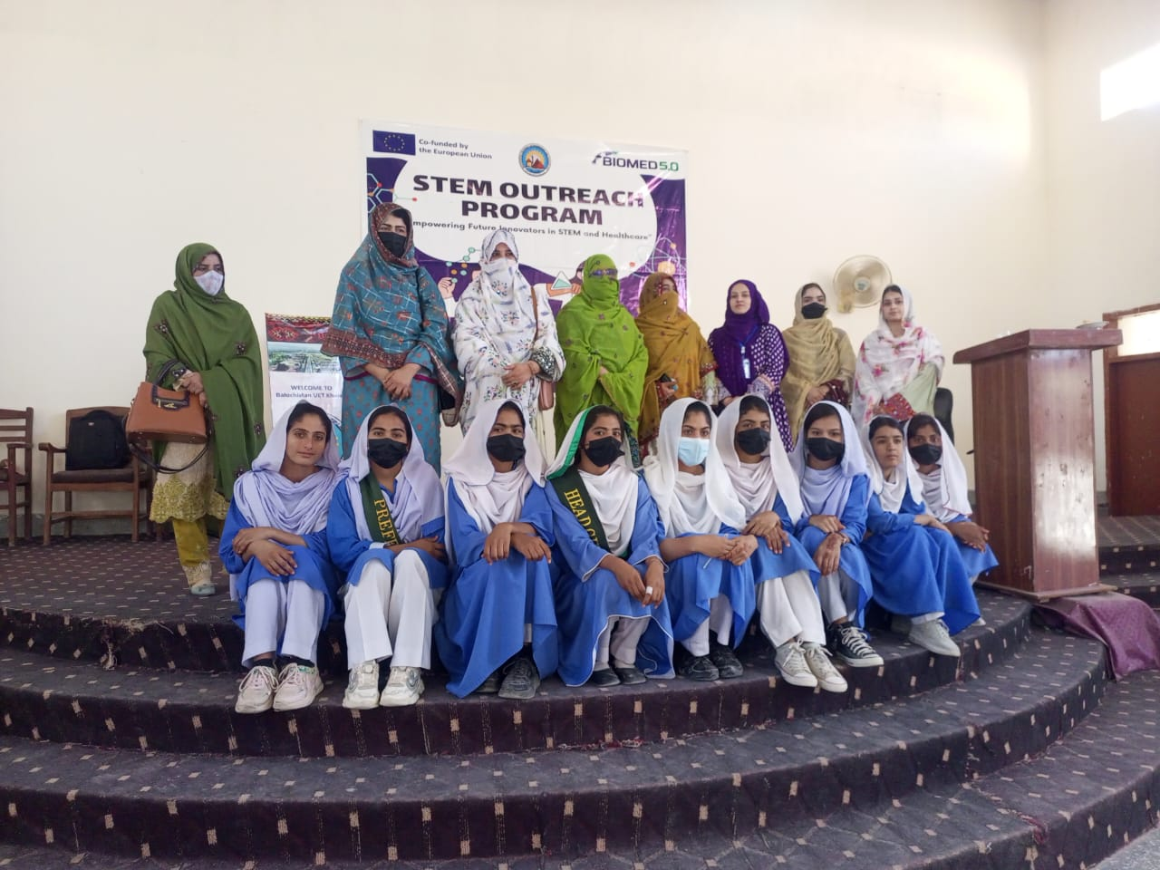

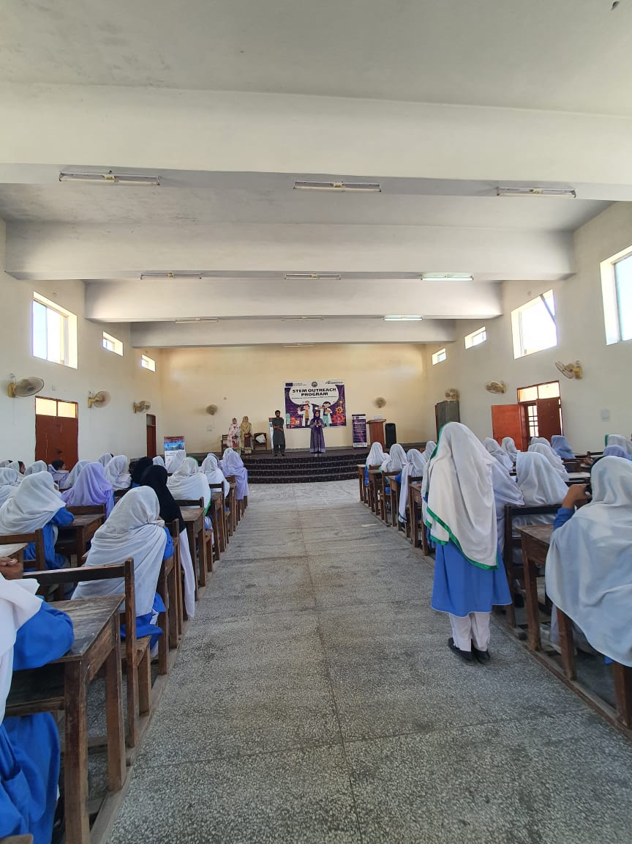

Note: This report is submitted for your review and serves as documentation of the activity's impact, outlining potential pathways for further educational engagements in Khuzdar aimed at inspiring more female students toward careers in science and technology.

Dr. Wazir Muhammad Dr. Nazia Ejaz

Participant In Contact Task Manager

BUET, Khuzdar BUET, Khuzdar